***Coding Academy by Orange***



MASTERPIECE PROJECT

**Title**: 7ISBEH

**developed by**: Eng. Yousef Alhindawi

## Orange Coding Academy - Irbid

First Cohort 2022

**Acknowledgments**

I would like to express my deepest gratitude to God Almighty for giving me the ability to complete my project, and I would also like to express my great appreciation to the programming academy from Orange for giving me the opportunity to be here. I am especially grateful for the help provided by our dearest trainers at the Academy, and I would like to commend the supervision provided by our valuable trainers starting from the Director of Irbid Academy Mr. Muhammad Freihat, job coach Hala Obeidat, technical trainer coach Alaa Qazaq and coach Hala Hamdan.

Abstract

This web application is an online store for selling vegetables and fruits.

This site was built to help local vegetable shops and farmers in my local community to sell their products and profit from them.

# Chapter 1: Introduction

## Problem Statement

Many shops and farmers in my local community find it difficult to market and sell their products. Therefore, this site was found to open new horizons and channels for marketing and selling.

## Solution

This site has come to solve the problem, this site was found to open new horizons and channels for marketing and selling and make it more reachable. If the customer wants to buy our products, buy the product he wants, deliver to the address he wants, and pay upon arrival.

# Chapter 2: Methodology

## 2.1 System Requirements

**A.**

|  |  |  |
| --- | --- | --- |
| **No** |  | Requirement Description |
| **1** | | The website allows users to sign in |
| **2** | | The website allows admins to sign in |
| **3** | | The website allows admin to access users’ requests. |
| **4** | | The website allows admin to show all user and our orders. |
| **5** | | The website allows admin to add new categories and new products. |

**B.**

|  |  |
| --- | --- |
| **No.** | Requirement Description |
|  | Ease of use: The website is user-friendly, simple, and responsive |
|  | Safety and confidentiality: No one allowed to access user requests information other  than the authorized person, who are admins. |

# Chapter 3: Technologies

## Programming Languages

|  |  |  |
| --- | --- | --- |
| **No** |  | Website |
| **1** | | HTML5 |
| **2** | | CSS3 – Bootstrap |
| **3** | | JavaScript |
| **4** | | PHP / Laravel |
| **5** | | MySQL |

## Database

Using MySQL to manage operations database.

There are 9 tables as shown in Shema below with necessary relation between them.

Tables: Users, admins, order histories, carts, associations, products, managers, categories and orders.

## Database schema:

## 

**Chapter 4: Design Models**

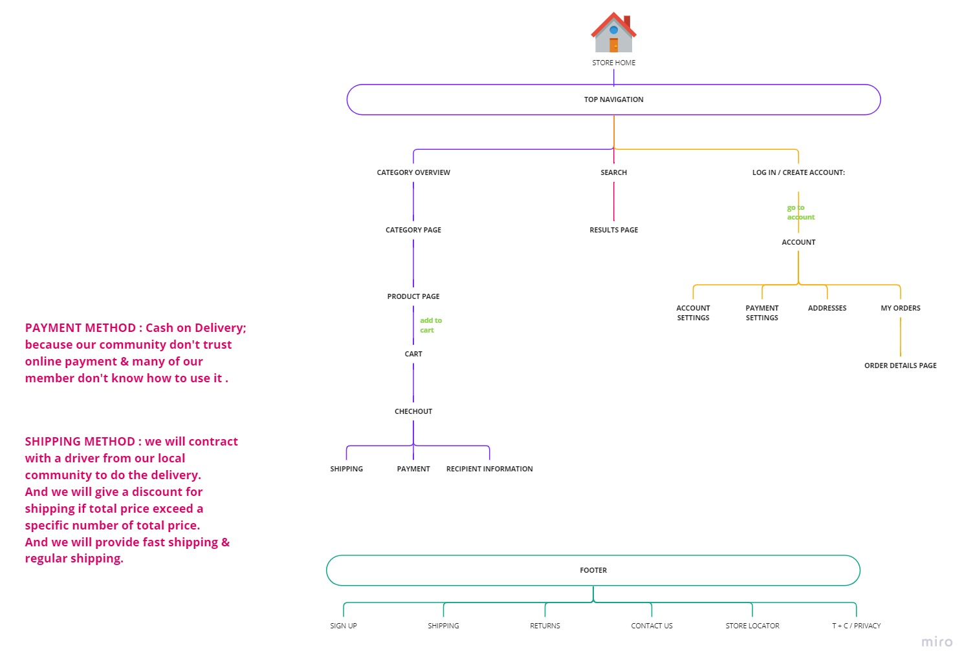

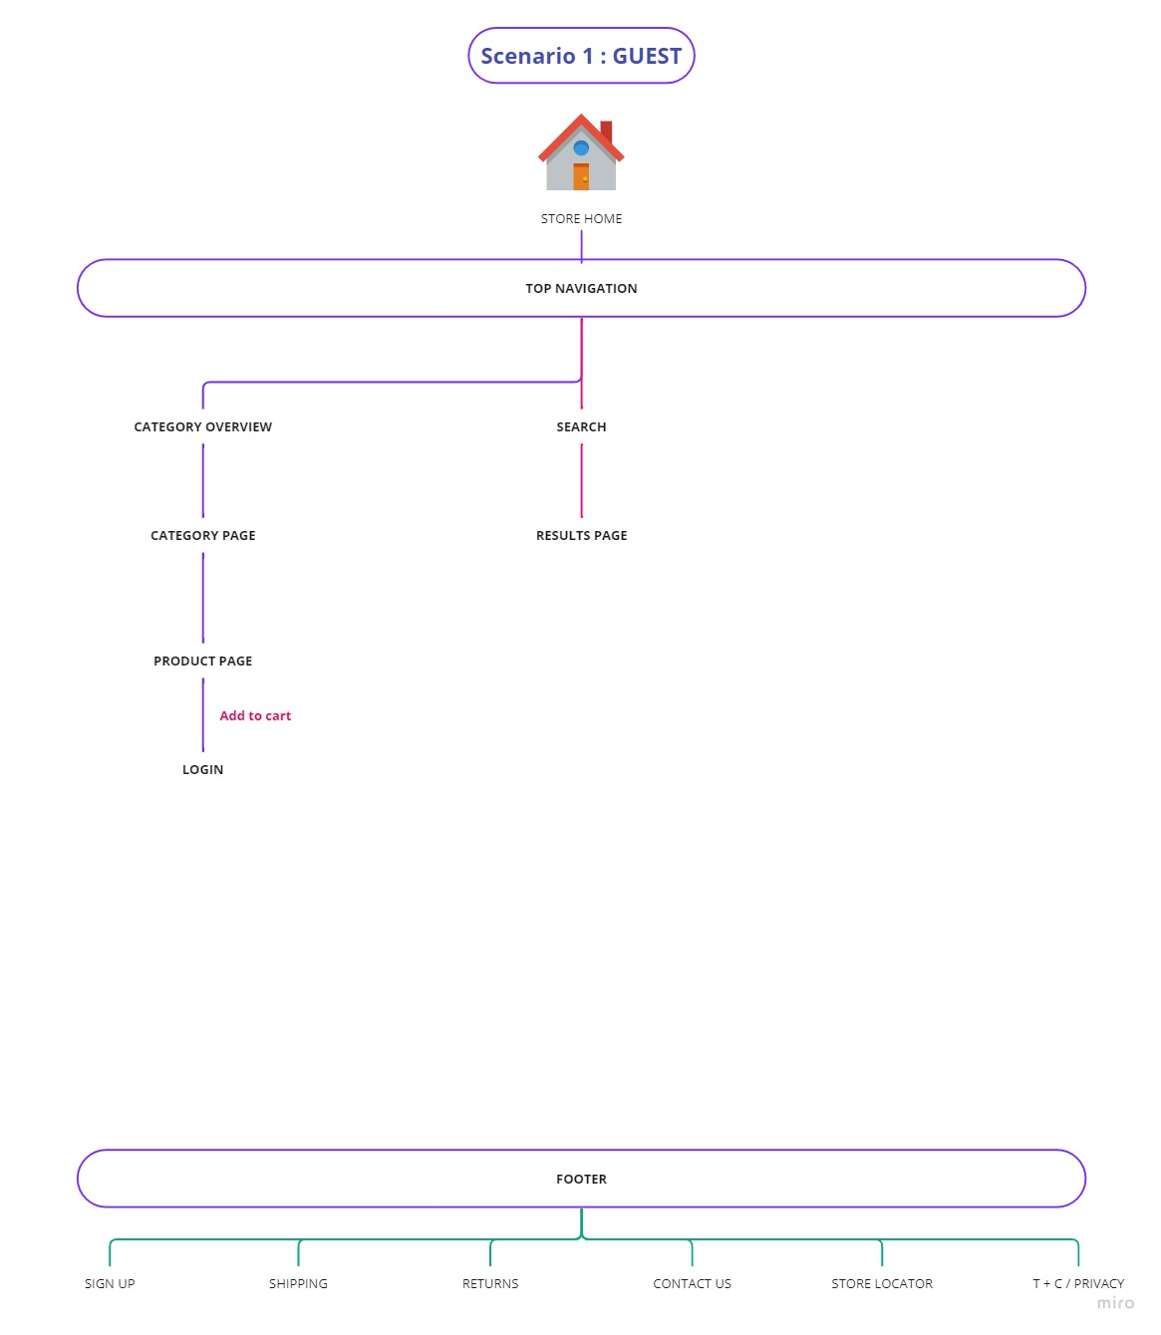

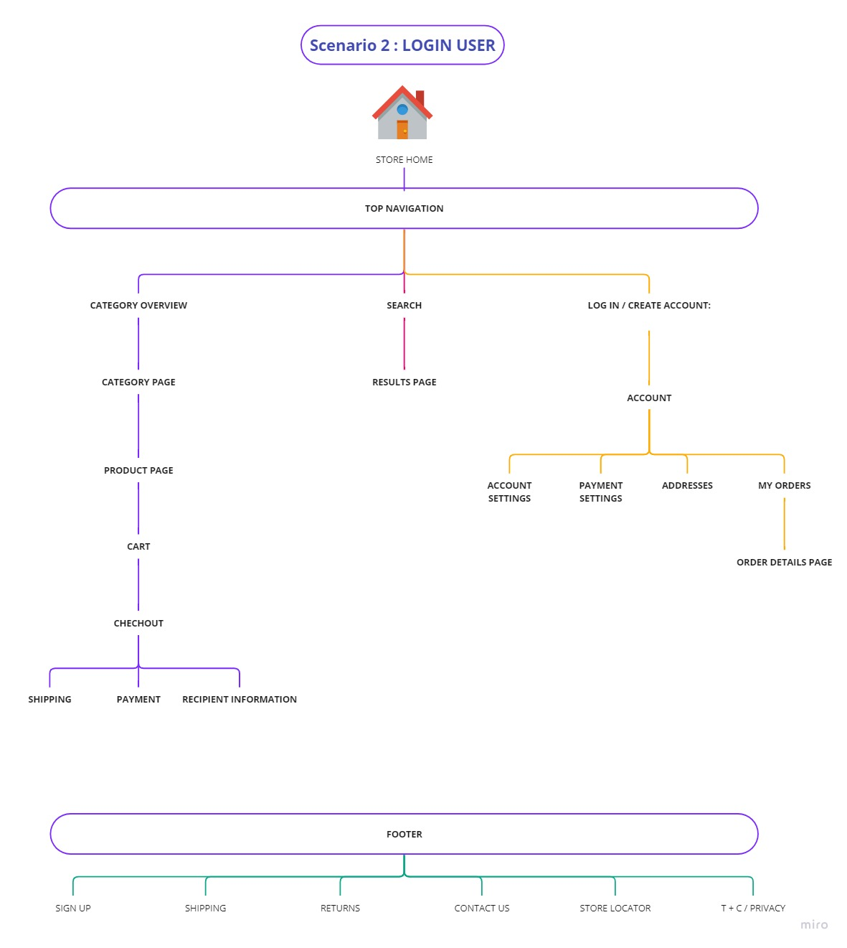

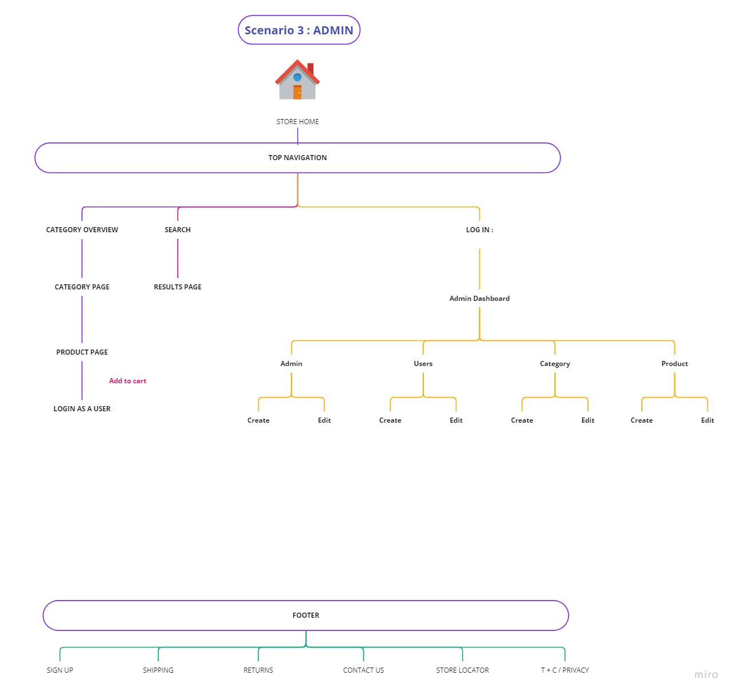

**Chapter 5: Experiments and results**

**Projects Features:**

* + 1. The website implements SEO.
    2. The website considers UX/UI design principles.
    3. The website is fully responsive.
    4. The website contains quiet animations.
    5. The website considers security by hashing strong passwords and activating the authorization demanding the user’s role.